## Duty alarm system

The *Duty Alarm System* provides (machinery) alarms to bridge, cabins and public areas for an unattended (unmanned) machinery space. The duty alarm system is configured upfront.

*Duty Alarm Panels* (DAP’s, see Figure 2‑5) at specific locations are connected with the automation system via the LAN-network. They display the information for machinery alarms and settings such as alarm group status, operation status, and on-duty selection.

The duty alarm system provides for signaling of Engine Control Room (ECR) to the cabins and bridge by a *Duty Alarm Panel* (DAP) or on a *Local Operator Panel* (LOP).

An engineer on duty can be selected from the *Operator Workstation* (OWS). He will be warned when a critical alarm is present in the unmanned engine room.

An engineer can be called on duty from the ECR on the OWS. Each station has its own caller identification.

When no DAP is used, the duty alarm system can be implemented with small or larger hardware panels as shown in the following figures:

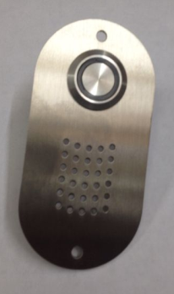 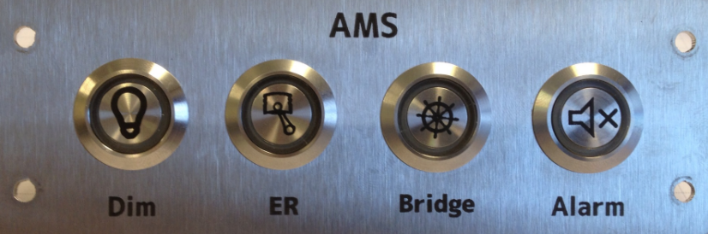

Figure 2‑4: typical Alarm panels

These panels come in the following editions, with their own respective operation.

|  |  |
| --- | --- |
| Panel horizontal-vertical | |
|  | |
|  | |
| Location of use: | Crew cabins that can be selected for Bridge duty as well as for ER duty |

|  |  |
| --- | --- |
| Panel horizontal-vertical | |
|  | |
|  | |
| Location of use: | Crew cabins that can be selected for ER duty |

|  |  |
| --- | --- |
| Panel horizontal-vertical | |
|  | |
|  | |
| Location of use: | Crew cabins that can be selected for bridge duty |

|  |  |
| --- | --- |
| Panel horizontal-vertical | |
|  | |
|  | |
| Location of use: | At each entrance door of the ER, or in the ECR |

|  |  |
| --- | --- |
| Panel horizontal-vertical | |
|  | |
|  | |
| Location of use: | Main or secondary bridge |

|  |  |
| --- | --- |
| Panel horizontal-vertical | |
|  | |
|  | |
| Location of use: | All spaces where Bridge duty crew can be available (no duty select) |

|  |  |
| --- | --- |
| **Button** | **Explanation** |
|  | Dim the button LED’s of that panel  Illuminates when panel is active |
|  | Silence the alarm  Illuminates when an alarm is active |
|  | No push activity  Illuminates when ER duty |
|  | No push activity  Illuminates when Bridge duty |
|  | Press for attended/unattended mode  Illuminates when attended |
|  | No push activity  Illuminates when timer is active |

Table 6: Alarm panel buttons

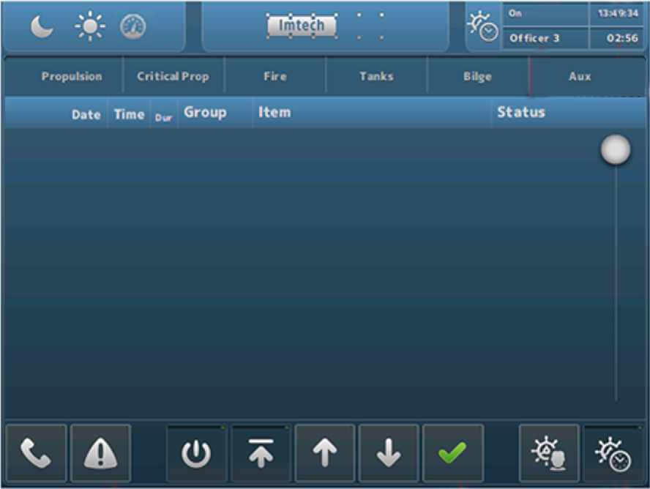

Figure 2‑5: Typical DAP screen